DAY 10  
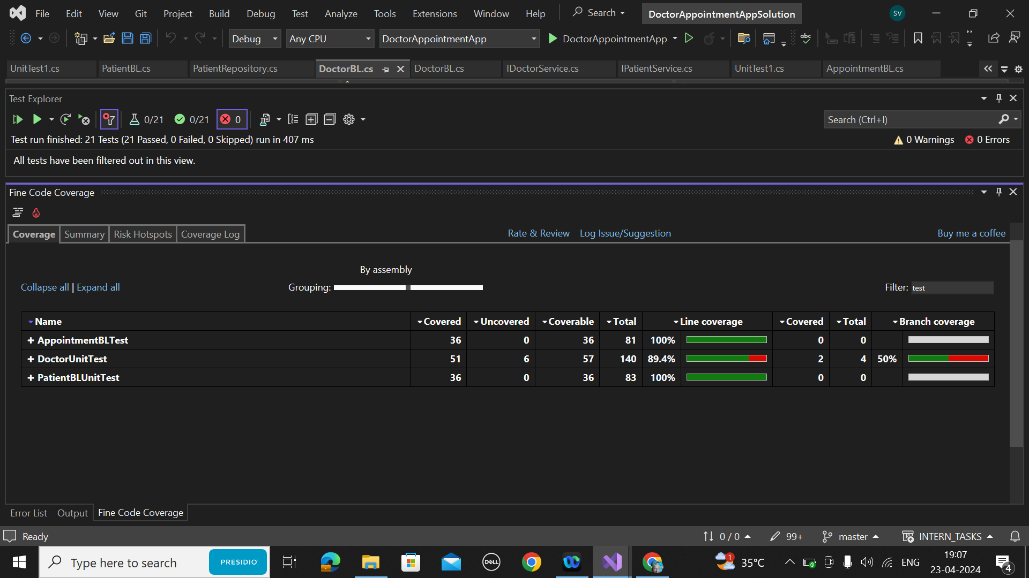

DOCTORBLTEST.CS

using NUnit.Framework;

using DoctorAppointmentAppModelLibrary;

using DoctorAppointmentAppBLLibrary;

using DoctorAppointmentAppDLLibrary;

using System.Collections.Generic;

namespace DoctorAppointmentAppTests

{

[TestFixture]

public class PatientBLTests

{

PatientBL _patientBL;

PatientRepository _patientRepo;

[SetUp]

public void Setup()

{

_patientRepo = new PatientRepository();

_patientBL = new PatientBL(_patientRepo);

}

[Test]

public void AddPatient_ShouldReturnPatientId_WhenPatientIsAdded()

{

var patient = new Patient { PatientId = 1, Name = "Test Patient" };

var result = _patientBL.AddPatient(patient);

Assert.AreEqual(patient.PatientId, result);

}

[Test]

public void GetPatientById_ShouldReturnPatient_WhenPatientExists()

{

var patient = new Patient { PatientId = 1, Name = "Test Patient" };

_patientBL.AddPatient(patient);

var result = _patientBL.GetPatientById(1);

Assert.AreEqual(patient, result);

}

[Test]

public void UpdatePatient_ShouldReturnUpdatedPatient_WhenPatientExists()

{

var patient = new Patient { PatientId = 1, Name = "Test Patient" };

_patientBL.AddPatient(patient);

patient.Name = "Updated Patient";

var result = _patientBL.UpdatePatient(patient);

Assert.AreEqual(patient, result);

}

[Test]

public void AddPatient_ShouldReturnZero_WhenPatientIsNotAdded()

{

var patient = new Patient { PatientId = 0, Name = "Test Patient" };

var result = _patientBL.AddPatient(patient);

Assert.AreEqual(0, result);

}

[Test]

public void GetPatientById_ShouldReturnNull_WhenPatientDoesNotExist()

{

var result = _patientBL.GetPatientById(999);

Assert.IsNull(result);

}

[Test]

public void UpdatePatient_ShouldReturnNull_WhenPatientDoesNotExist()

{

var patient = new Patient { PatientId = 999, Name = "Nonexistent Patient" };

var result = _patientBL.UpdatePatient(patient);

Assert.IsNull(result);

}

}

}

PATIENTBL.CS  
using NUnit.Framework;

using DoctorAppointmentAppModelLibrary;

using DoctorAppointmentAppBLLibrary;

using DoctorAppointmentAppDLLibrary;

using System.Collections.Generic;

namespace DoctorAppointmentAppTests

{

[TestFixture]

public class PatientBLTests

{

PatientBL _patientBL;

PatientRepository _patientRepo;

[SetUp]

public void Setup()

{

_patientRepo = new PatientRepository();

_patientBL = new PatientBL(_patientRepo);

}

[Test]

public void AddPatient_ShouldReturnPatientId_WhenPatientIsAdded()

{

var patient = new Patient { PatientId = 1, Name = "Test Patient" };

var result = _patientBL.AddPatient(patient);

Assert.AreEqual(patient.PatientId, result);

}

[Test]

public void GetPatientById_ShouldReturnPatient_WhenPatientExists()

{

var patient = new Patient { PatientId = 1, Name = "Test Patient" };

_patientBL.AddPatient(patient);

var result = _patientBL.GetPatientById(1);

Assert.AreEqual(patient, result);

}

[Test]

public void UpdatePatient_ShouldReturnUpdatedPatient_WhenPatientExists()

{

var patient = new Patient { PatientId = 1, Name = "Test Patient" };

_patientBL.AddPatient(patient);

patient.Name = "Updated Patient";

var result = _patientBL.UpdatePatient(patient);

Assert.AreEqual(patient, result);

}

[Test]

public void AddPatient_ShouldReturnZero_WhenPatientIsNotAdded()

{

var patient = new Patient { PatientId = 0, Name = "Test Patient" };

var result = _patientBL.AddPatient(patient);

Assert.AreEqual(0, result);

}

[Test]

public void GetPatientById_ShouldReturnNull_WhenPatientDoesNotExist()

{

var result = _patientBL.GetPatientById(999);

Assert.IsNull(result);

}

[Test]

public void UpdatePatient_ShouldReturnNull_WhenPatientDoesNotExist()

{

var patient = new Patient { PatientId = 999, Name = "Nonexistent Patient" };

var result = _patientBL.UpdatePatient(patient);

Assert.IsNull(result);

}

}

}

APPOINTMENTBL.CS  
using DoctorAppointmentAppBLLibrary;

using DoctorAppointmentAppDLLibrary;

using DoctorAppointmentAppModelLibrary;

namespace DoctorAppointmentAppTests

{

[TestFixture]

public class AppointmentBLTests

{

AppointmentBL _appointmentBL;

AppointmentRepository _appointmentRepo;

[SetUp]

public void Setup()

{

_appointmentRepo = new AppointmentRepository();

_appointmentBL = new AppointmentBL(_appointmentRepo);

}

[Test]

public void ScheduleAppointment_ShouldReturnAppointmentId_WhenAppointmentIsScheduled()

{

var appointment = new Appointment { AppointmentId = 1, AppointmentDate = DateTime.Now, Availability = true };

var result = _appointmentBL.ScheduleAppointment(appointment);

Assert.AreEqual(appointment.AppointmentId, result);

}

[Test]

public void CancelAppointment_ShouldReturnCancelledAppointment_WhenAppointmentExists()

{

var appointment = new Appointment { AppointmentId = 1, AppointmentDate = DateTime.Now, Availability = true };

_appointmentBL.ScheduleAppointment(appointment);

var result = _appointmentBL.CancelAppointment(1);

Assert.AreEqual(appointment, result);

}

[Test]

public void RescheduleAppointment_ShouldReturnUpdatedAppointment_WhenAppointmentExists()

{

var appointment = new Appointment { AppointmentId = 1, AppointmentDate = DateTime.Now, Availability = true };

_appointmentBL.ScheduleAppointment(appointment);

var result = _appointmentBL.RescheduleAppointment(1);

Assert.AreEqual(appointment, result);

}

[Test]

public void ScheduleAppointment_ShouldReturnZero_WhenAppointmentIsNotScheduled()

{

var appointment = new Appointment { AppointmentId = 0, AppointmentDate = DateTime.Now, Availability = true };

var result = _appointmentBL.ScheduleAppointment(appointment);

Assert.AreEqual(0, result);

}

[Test]

public void ScheduleAppointment_ShouldThrowException_WhenAppointmentIsNull()

{

Appointment appointment = null;

Assert.Throws<ArgumentNullException>(() => _appointmentBL.ScheduleAppointment(appointment));

}

[Test]

public void CancelAppointment_ShouldThrowException_WhenAppointmentIdIsInvalid()

{

Assert.Throws<ArgumentException>(() => _appointmentBL.CancelAppointment(-1));

}

[Test]

public void RescheduleAppointment_ShouldThrowException_WhenAppointmentIdIsInvalid()

{

Assert.Throws<ArgumentException>(() => _appointmentBL.RescheduleAppointment(-1));

}

}

}